**Final Project**

**Intro to Computer Science**

**CSC - 103 - 001**

**Friar Cups**

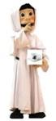

**Providence College**

**Fall 2020**

**Submitted to: Dr. Reza Sadeghi**

**Friar Cups Team members/Role**

Mike Burke, [mburke23@friars.providence.edu](mailto:mburke23@friars.providence.edu)- Head designer, helped with site graphics/menu

Justin Conforti, [jconfort@friars.providence.edu](mailto:jconfort@friars.providence.edu)- Head editor/menu

CJ Khoury, [ckhoury@friars.providence.edu](mailto:ckhoury@friars.providence.edu)- head merch designer/menu

Olivia Sprofera, [osprofer@friars.providence.edu](mailto:osprofer@friars.providence.edu)- head of social media/gallery page/menu

Mike Flynn, [mflynn19@friars.providence.edu](mailto:mflynn19@friars.providence.edu)- head manager, organized prices and team page/menu

*All of our members had a significant role in creating our first prototype website

**Table of Contents**

Team members, emails, and roles…………… Pg. 1

Website outline………………………………..Pg.3-4

* Our story
* Basic outline of site
* logo

Website Goal…………………………………..Pg.5

Website specific details and tabs……………...Pg.6-16

* Home page
* Menu Page
* Team page
* Contact Page
* Merchandise Page
* Gallery page

Coding Process……………………………….Pg.17

What we would change/improve going forward..Pg.18

Website link and sources………………………..Pg.19

**Our Story**

Friar Cups started out as a dream until five Providence College students turned it into a reality. Working with the college we were able to establish a little café in alumni hall to serve our wonderful community. What makes us so great is we only hire students so we are not only serving the freshest coffee on campus but we create more fun jobs for our on campus students. At Friar Cups we love to have fun and make delicious coffee!



**Brief site outline**

Coffee shop: “Friar Cups”

* + cold drinks (iced coffee, cold brew, iced latte, fresh juice)
  + hot drinks (hot coffee, hot latte, tea, espresso, americano)
  + seasonal specials (pumpkin spice, peppermint, white chocolate)
  + Eats (bagel, muffin, croissant, sandwiches, cookie)
  + Specials
* Merchandise Tab
  + Sell mugs, roasts, pastries, K-cups, Gift Cards,
  + Clothing (ex. T-shirts, hats, sweatshirts, sweatpants)
* About
  + Write something about ourselves (staff)
  + Our Story
  + Careers / employment page
  + Description of how each drink is made, ingredients
* Mobile ordering
  + Feature used so customers can order drinks in advance.
* Gallery/reviews
  + Customers will be able to submit reviews on our website
  + Also be able to submit pictures and see them on our sight and social media
* Contact
  + Location information (1 Cunningham Square, Providence, RI 02918)
  + Hours of operation (Tuesday- Sunday 6am-3pm)

**Website Goal/Objective**

The Goal of our Friar Cups website is to create the best new dining spot on campus for all students and faculty at providence college. We wanted to make our website attractive with a modern design to attract customers. We make fresh coffee everyday along with our unique specials to keep customers coming back. Friars Cups staff has the best customer service in order to satisfy all customer needs. We developed a prototype that we believe we could present to the head of providence college to make this dream into a realty. Our ultimate goal would be to actually open a new fun dining spot on Providence college campus.

**Home Page**

This is our opening page to our website. It was critical for us to make a unique design to catch users eyes. Therefore, we came up with a great slogan (freshest cups in friartown) and implemented artsy background photos to show a clean design. We also added our story to this page because we wanted to get our message to our customers right away and let them know what we believe in. You can see the design of this page in the images below on the next page:

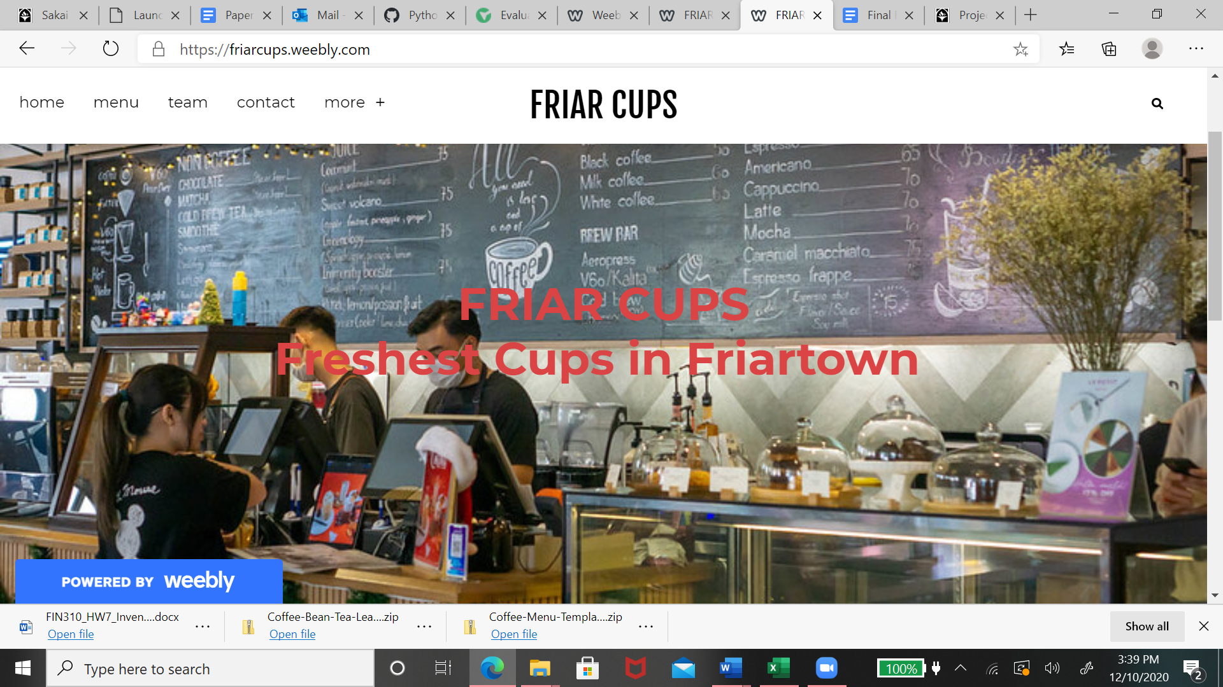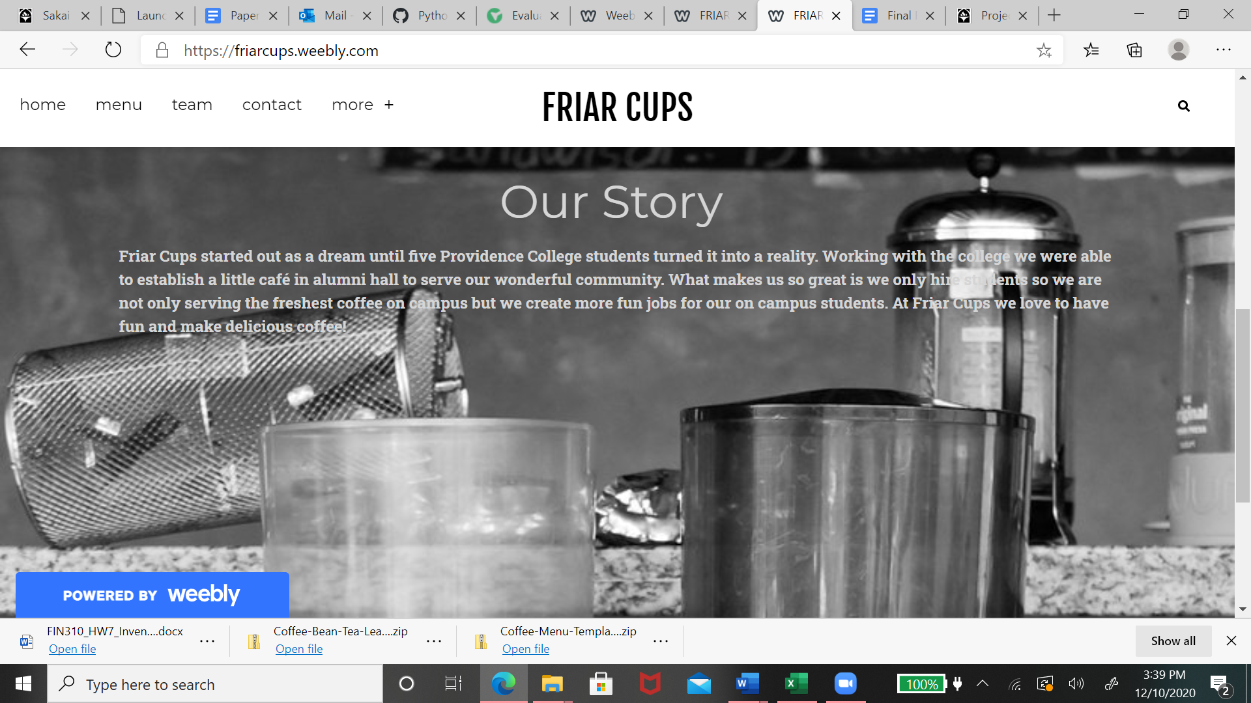

**Menu Page**

The menu page was the most important part of our project because it is what our business is all about. We spent a good amount of time brainstorming the ideal cafe menu. We included Hot Drinks, Cold Drinks, Speciality Drinks, Speciality food (seasonal), Breakfast. We designed a menu that caters to young college students by putting different fancy drinks for cheaper prices. Our seasonal specialty food menu is also a very important part of our project because it is a good way to have a variety of foods and gives people something to look forward to. Our coffee is made in house, along with fresh baked goods and teas. Lastly, we worked with the developers of PC Mobile app (PC central hub app) to implement an online order system so customers can order ahead of time to avoid long lines.Our menu design is available below:

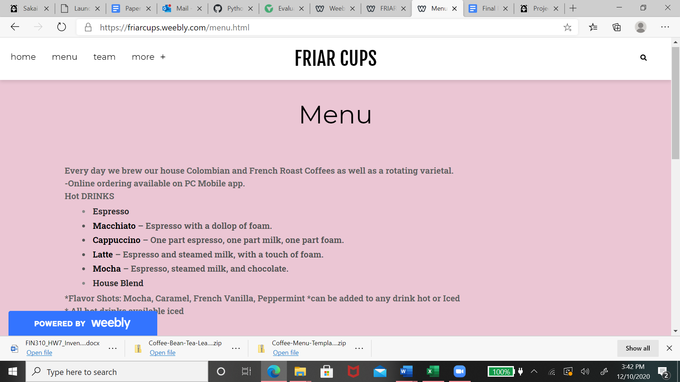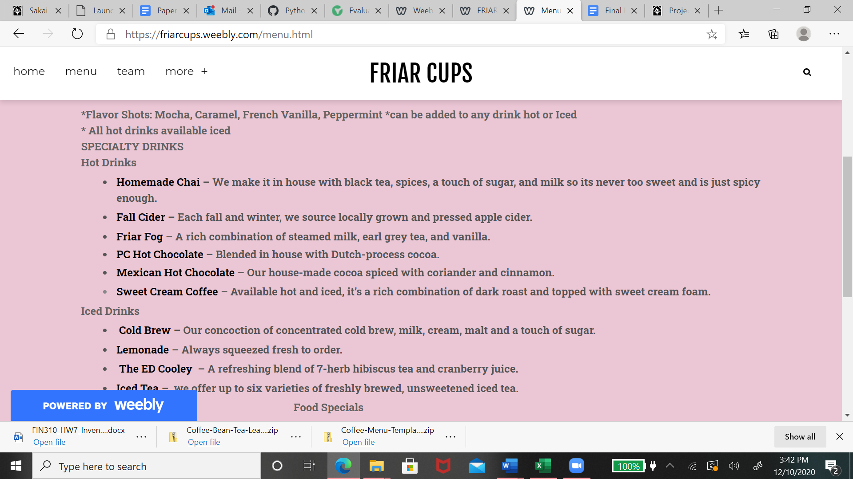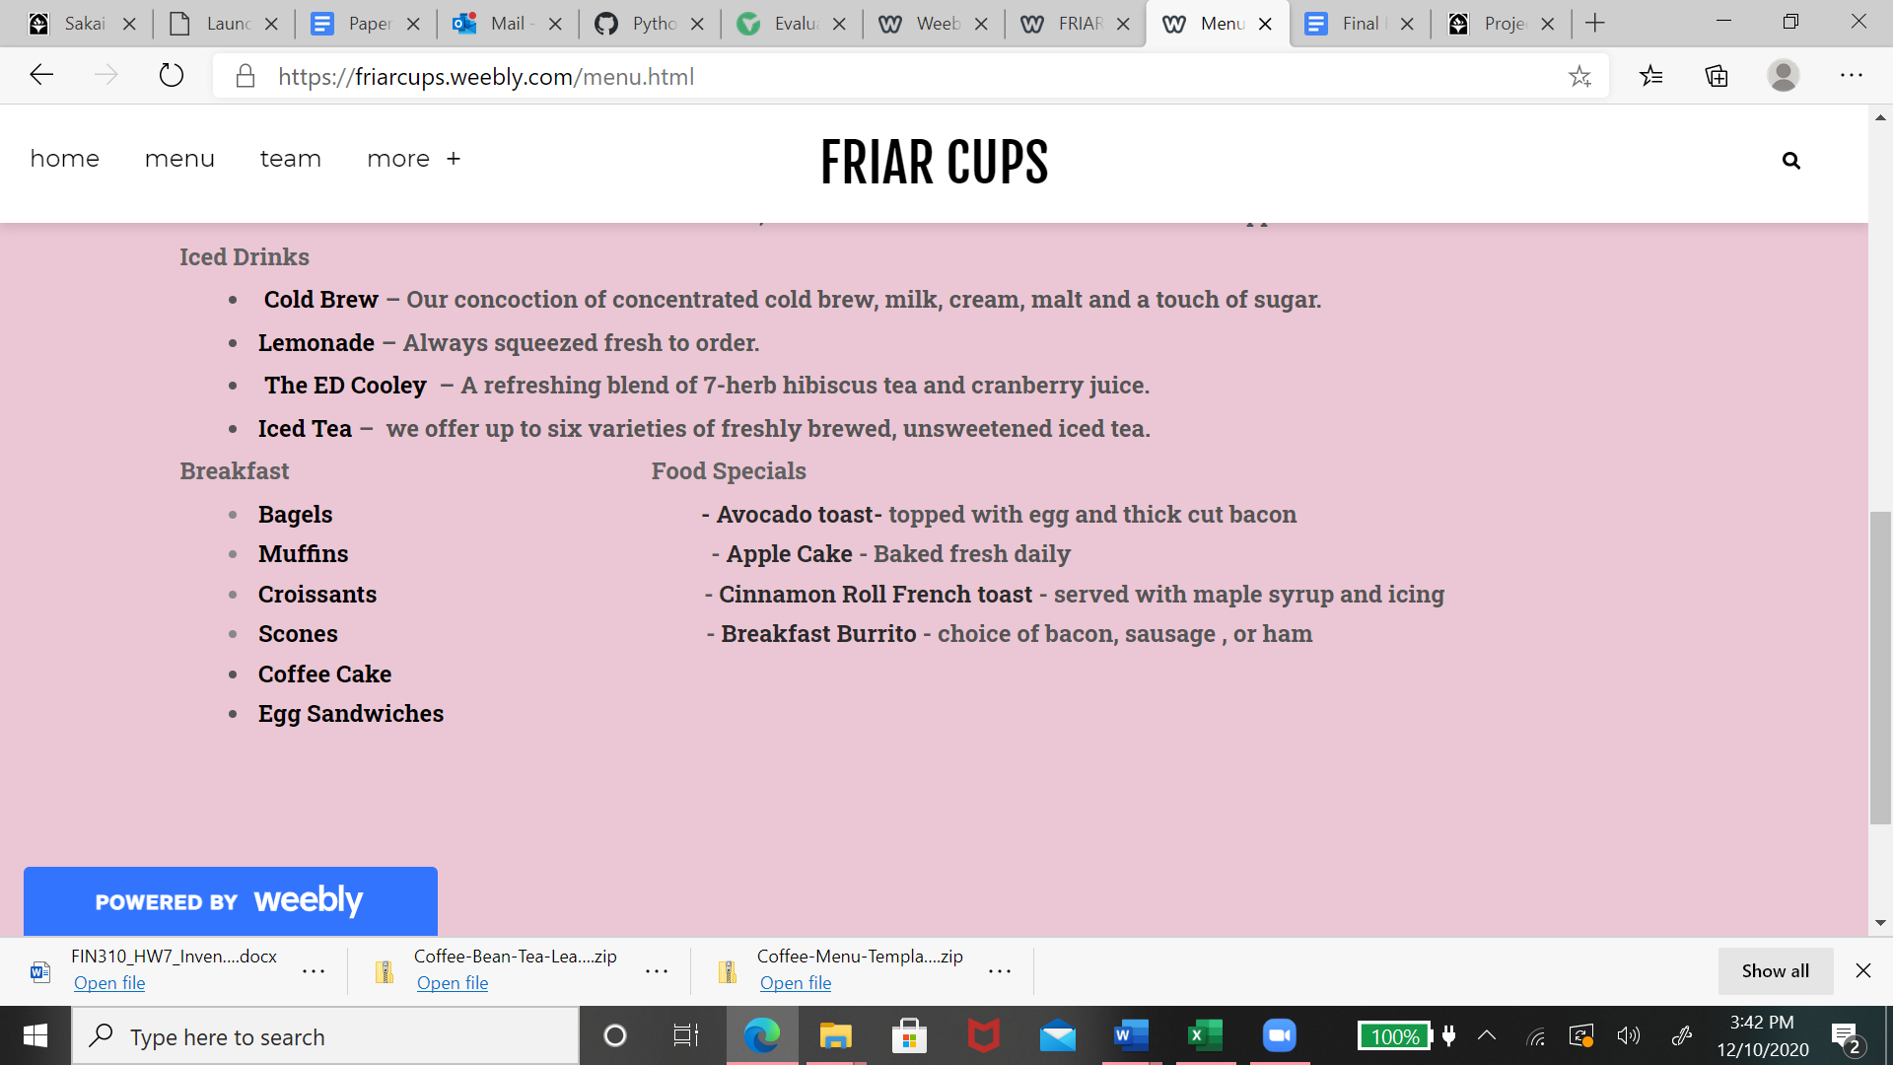

**Team Page**

Our team page is very simple. It is just a page to get to know our staff and their jobs in the store. All of our staff are currently undergraduates at Providence College. We thought only hiring PC students would be a good way to connect with our consumers and create more jobs for PC students. Our team page is displayed below:

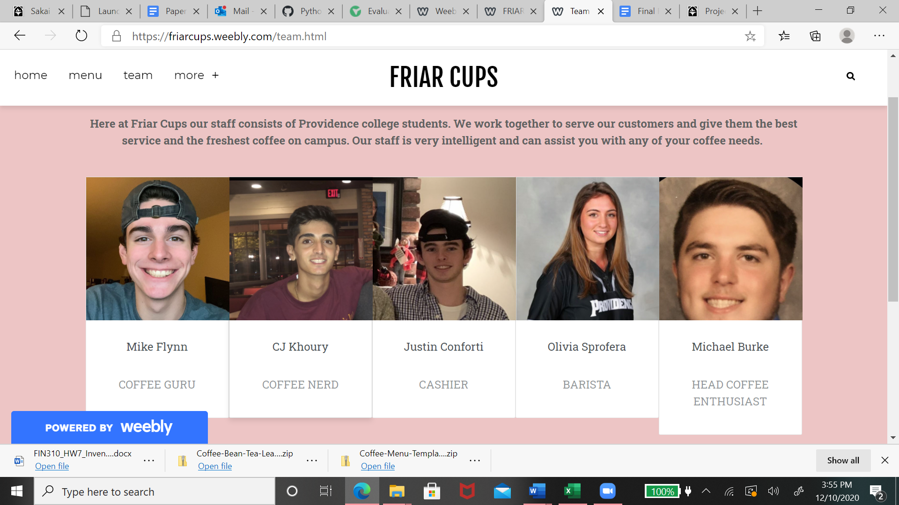

**Contact Page**

Our contact page was created so people know where we are located, how to get in touch with us and a way to ask questions and form complaints. This is a very simple page and it is something every website consists of. All of our contact info is displayed below:

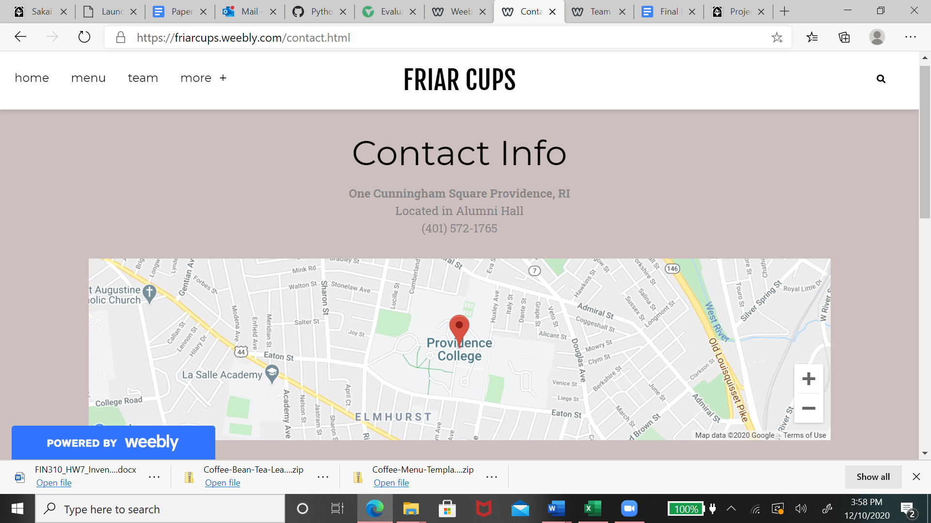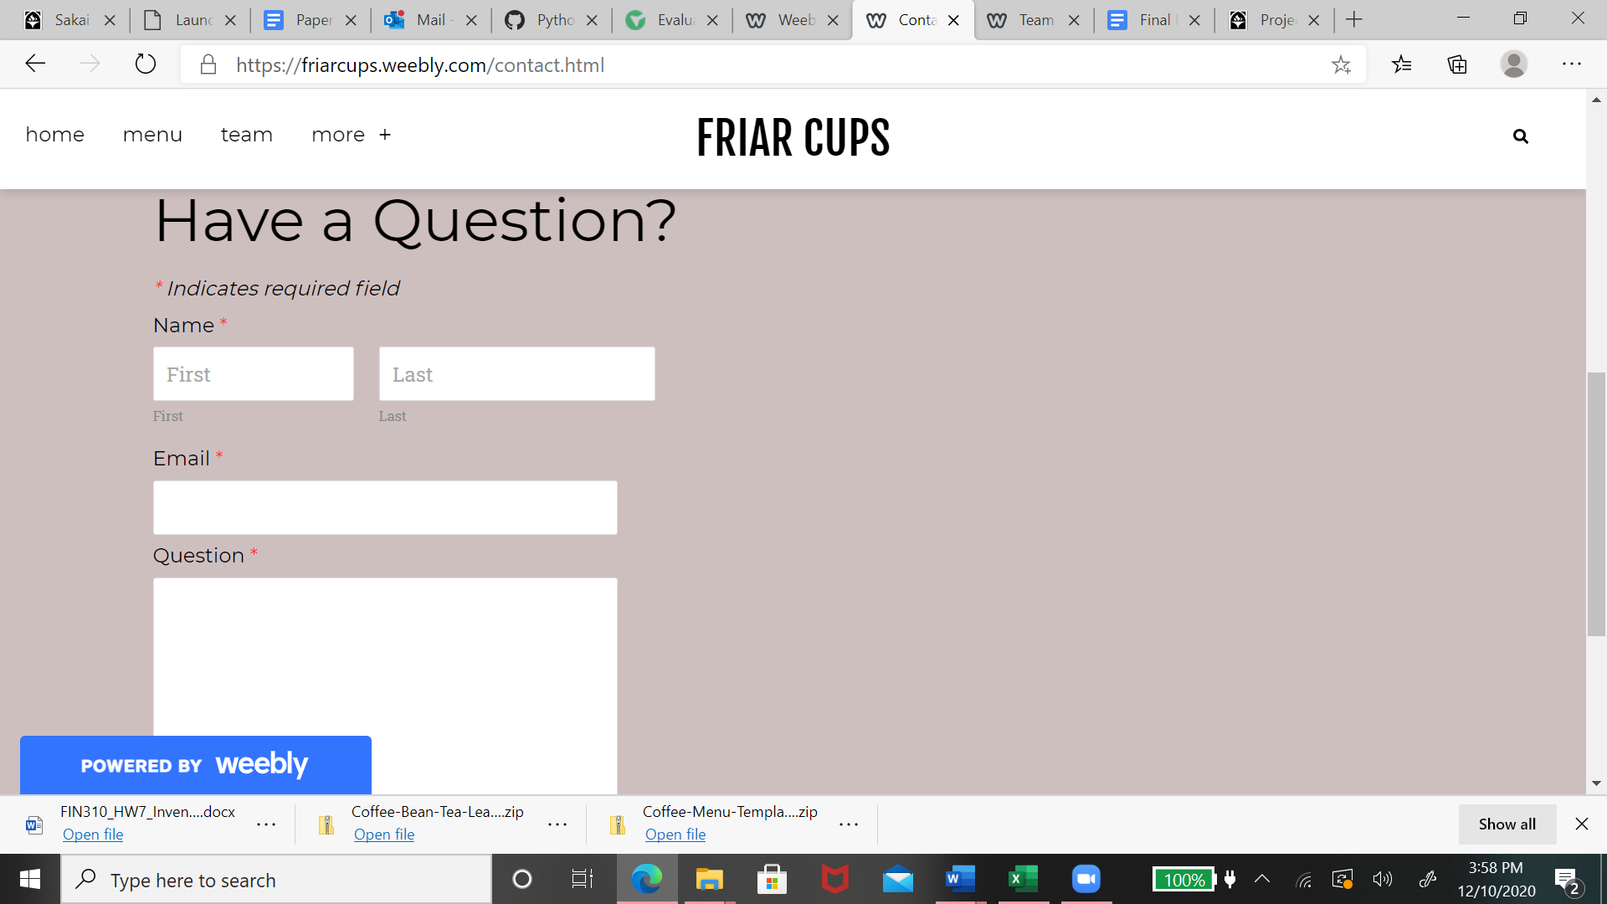

**Merchandise Page**

To create more Revenue we thought it would be a great idea to sell our own merch and house blend coffee for students to take back to their dorms. We designed sweatshirts, cups, and sweatpants, along with our own ground coffee bag so students can represent our Friar Cups all around campus. We thought this is another way to advertise our store and get notice around campus. We also are going to give away free merch every month to our most loyal customers. All of our merch is displayed below:

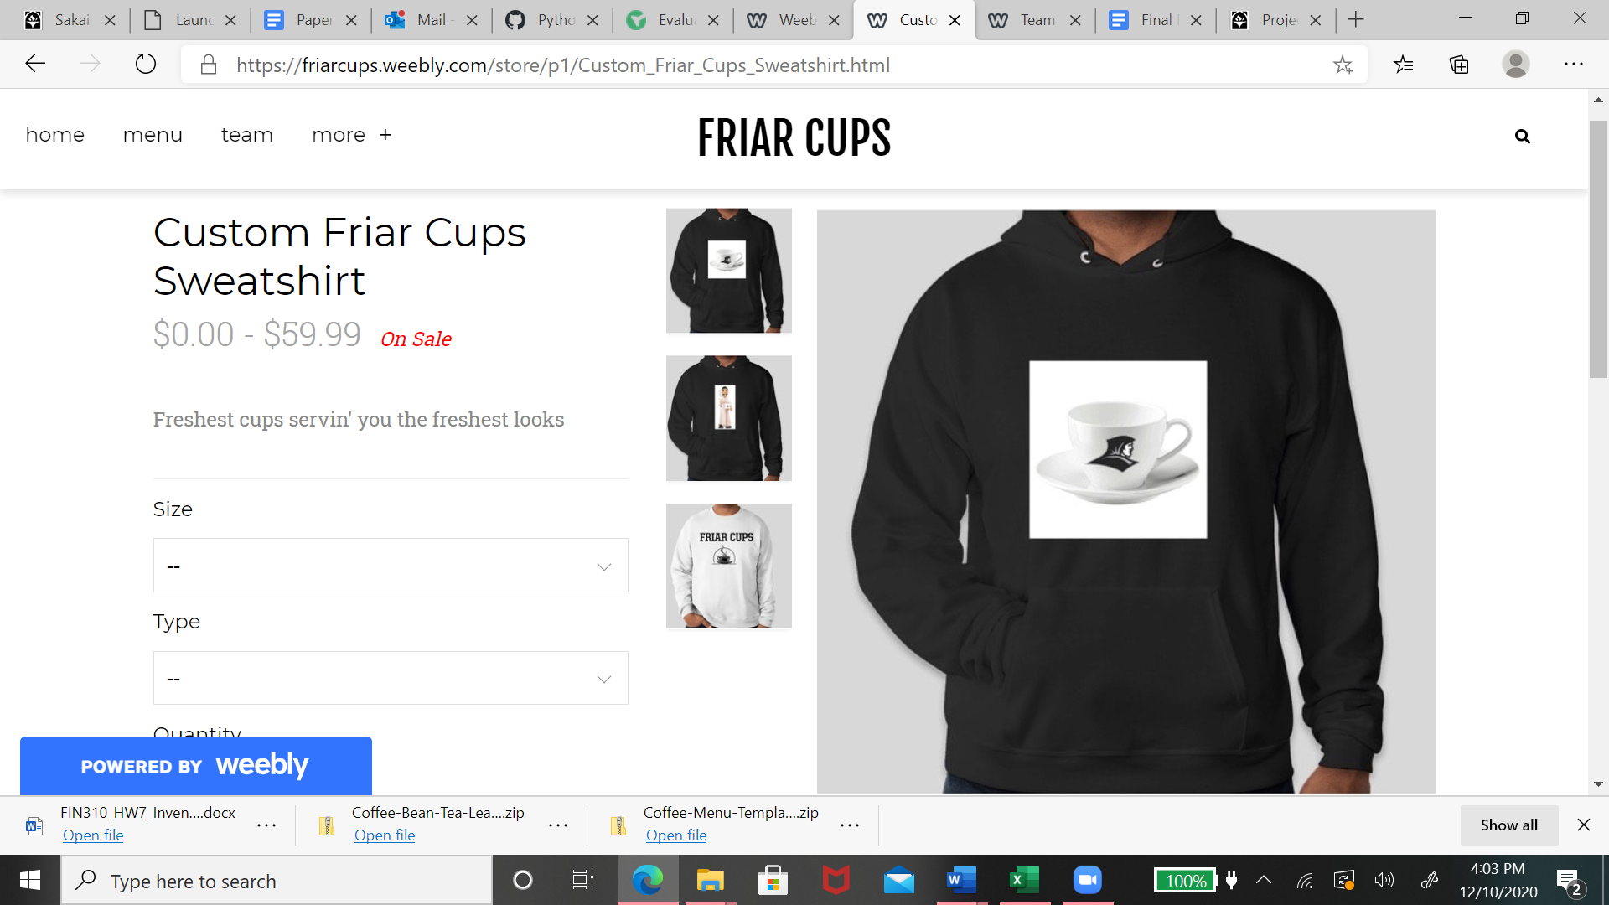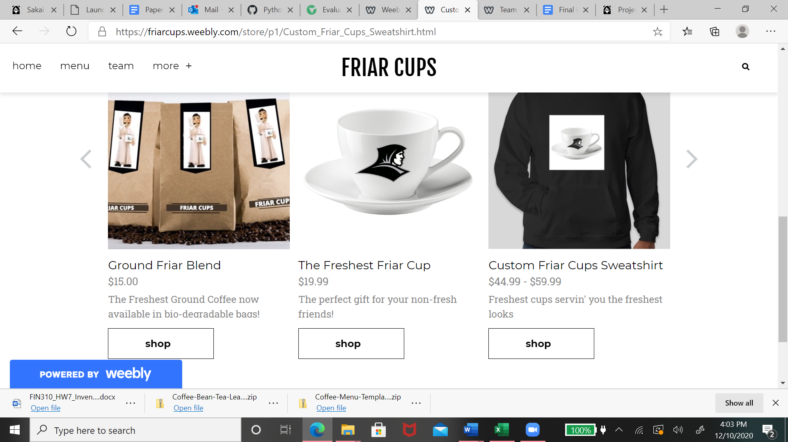

**Gallery Page**

Lastly, we have our gallery page. We thought this would be a cool idea to show off our creative drinks. Our gallery consists of customer photos as well as our own. We want to show people how Friar Cups has the best coffee along with the best presentation. Our gallery is displayed below:

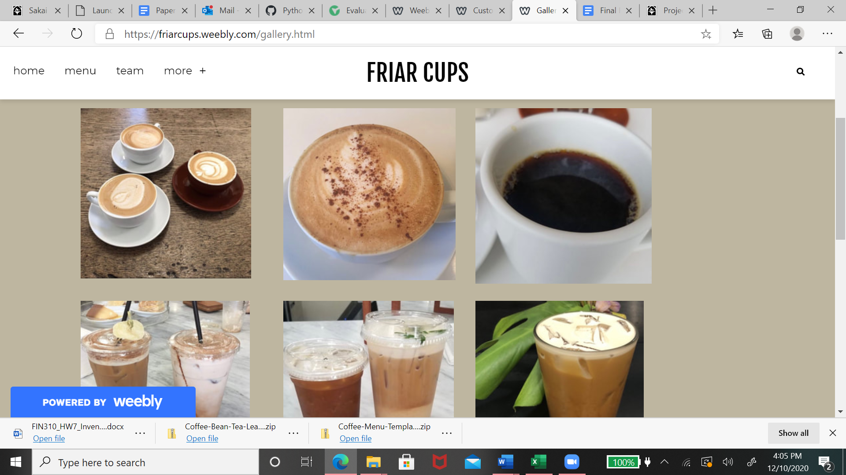

**Coding process**

As we started to build the site we noticed there were big challenges in coding such a complex website. Friar cups wanted such a great design and clean modern website. Therefore, we reached out to website developers and designers to ensure our prototype was as good as it can be if we were to present to the college. As far as the coding we learned many new things from watching the following videos you provided for us and other resources. Our biggest problem we encountered was getting all the necessary software compatible to our computers. This took the most time to figure out and to get off the ground and running.. We experimented with django and tried to add admins, HTML, and SQlite aspects to our website. Our original design did not meet our satisfaction, therefore, we seeked help to show the optimal value and idea of Friar cup. Saying that we were able to learn a lot about different functions and aspects of coding. For example in our website we were able to see how it constructed the GUI aspect and ran certain webbapps in the background to make sure all pages of the website ran smoothly and without many errors. In all, we enjoyed trying to find creative ways to meet our optimal design for Friar cups. We hope to continue to develop our website and speak with other coffee shop owners so we can really have a shot of putting our dream of the Friar Cups into a reality.

**Future Improvements**

After speaking with outside resources and presenting our idea to our teacher and classmates, we immediately notice simple improvements we could make to our site. First is a login in page. This will allow users to create a profile and save past orders and qualify for customer deals. This is a key part for coffee shops because it allows customers to be interactive and involved with our store. Next we would add a mobile ordering concept on the site. Having our own mobile ordering section would increase revenue and be more convenient to customers. Our goal is to have speedy service and this is just one of many ways to achieve that. Lasty, Down the line, when we figure out our final product and the right menu we want to take the time to recode our whole website by ourselves. This will require many things. First we as a group need to develop our computer software language so we can use other coding languages or more advanced coding languages. Next we will need to consult with outside partners. Lastly, we will be looking for investors or other people who are knowledgeable in the coding field to make sure we have enough money to start this business as well as make sure our website is always up to date. Friar Cups wants to thank you for reading our final report and we hope one day Friar Cups will find its home on the Providence college campus one day.

Website link

[**https://friarcups.weebly.com**](https://friarcups.weebly.com/)

Sources

[How to Build an E-commerce Website with Django and Python - YouTube](https://www.youtube.com/watch?v=YZvRrldjf1Y&feature=youtu.be)

<https://www.youtube.com/watch?v=YZvRrldjf1Y&feature=youtu.be>

[Python · GitHub](https://github.com/python)